SPECIFICATION DOCUMENT FOR AI-POWERED MUSIC RECOMMENDATION WEB APPLICATION
Group 3

1. Introduction

1.1 Purpose
The purpose of this document is to define the functional and non-functional requirements of an AI-powered music recommendation web application with its user interface. This platform allows users to stream music while leveraging artificial intelligence to provide personalized song recommendations.

1.2 Scope
The web application will allow users to:
- Listen to music from an integrated music library.
- Receive AI-driven music recommendations based on user behavior and preferences.
- Create and manage personalized playlists.
- Explore music by genre, mood, or activity.
- Provide feedback on recommendations to improve future suggestions.
The system will be accessible via web browsers and will integrate with third-party music APIs for content delivery.

1.3 Definitions, Acronyms, and Abbreviations
- AI: Artificial Intelligence
- UI/UX: User Interface/User Experience
- API: Application Programming Interface
- SRS: Software Requirements Specification

1.4 References
- IEEE 830-1998 – Recommended Practice for Software Requirements Specifications (ieeexplore, 2024)
- Spotify API Documentation (spotify, 2024)
- OWASP Security Best Practices (codacy, 2025)

1.5 Document overview
This Software Requirements Specification (SRS) document is structured to provide a detailed and organized description of the requirements for the development of the "Web Application for Listening to Smart Music Suggestions with AI". The document is divided into the following sections:
- Introduction: Defines the purpose, scope, and key terms of the project, along with references to relevant standards.
- Overall Description: Provides a high-level overview of system functionality, user characteristics, constraints, and dependencies.
- Specific Requirements: Details functional and non-functional requirements, including user authentication, music playback, AI recommendations, performance, security, and scalability.
- External Interface Requirements: Describes user interfaces, hardware/software needs, and communication protocols.
- Other Requirements: Covers additional system attributes, such as analytics and administrative features.
- Appendices: Includes supplementary materials like a glossary, UI mockups, and third-party API references.
This structured approach ensures clarity and completeness, helping stakeholders understand system goals and requirements effectively

2. Overall Description

2.1 Product Perspective
The web application is a standalone system that integrates with third-party music APIs (e.g., Spotify, YouTube Music) to provide music streaming and AI-driven recommendations. It will be accessible via modern web browsers.

2.2 Product Functions
- User registration and authentication.
- Music playback with controls (play, pause, skip, volume).
- AI-based music recommendation engine.
- Playlist creation and management.
- Search and filter music by genre, mood, or activity.

2.3 User Characteristics
- Primary Users: Music enthusiasts who want personalized music recommendations. These users are typically tech-savvy individuals who value discovering new music tailored to their tastes and listening habits. They may include casual listeners, audiophiles, or even professional musicians seeking inspiration.
- Secondary Users: Developers and administrators who maintain the system. These users are responsible for ensuring the platform runs smoothly, updating the recommendation algorithms, and troubleshooting any technical issues. They may also analyze user data to improve the system's performance and user experience.

2.4 Constraints
- The system must comply with copyright laws and licensing agreements for music content. This includes ensuring that all music tracks and metadata are legally sourced and that proper royalties are paid to artists and copyright holders. Non-compliance could result in legal penalties and damage to the platform's reputation.
- The AI recommendation engine must operate in real-time with minimal latency. Users expect instant recommendations as they interact with the platform, and any delays could lead to frustration and a poor user experience.
- The application must be compatible with major web browsers (Chrome, Firefox, Safari, Edge).

2.5 Assumptions and Dependencies
- The system assumes users have a stable internet connection. Without a reliable connection, users may experience interruptions in music streaming or delays in receiving recommendations. Offline functionality could be considered for future updates.
- The system depends on third-party music APIs for content delivery. These APIs provide access to a vast library of music tracks and metadata, but any changes or disruptions to these services could impact the platform's functionality.
- The AI recommendation engine relies on user data for accurate suggestions. This includes data such as listening history, user preferences, and feedback. Ensuring data privacy and security will be critical to maintaining user trust and complying with regulations like GDPR.

3. Specific Requirements

3.1. Functional Requirements
1. Login/Register Function
- In the login function, the users click the “Account” textbox input to enter their username and click the “Password” textbox input to enter their password.
- When they finish entering information, they must click the “Login” button so the system can check their account.
- The users can click "Forget Password” if they don't remember their password to log in.
- Users can log in to the website by using accounts via Google and Facebook
- If they don’t have account to login this application, they can create a new account by click “Register” button.
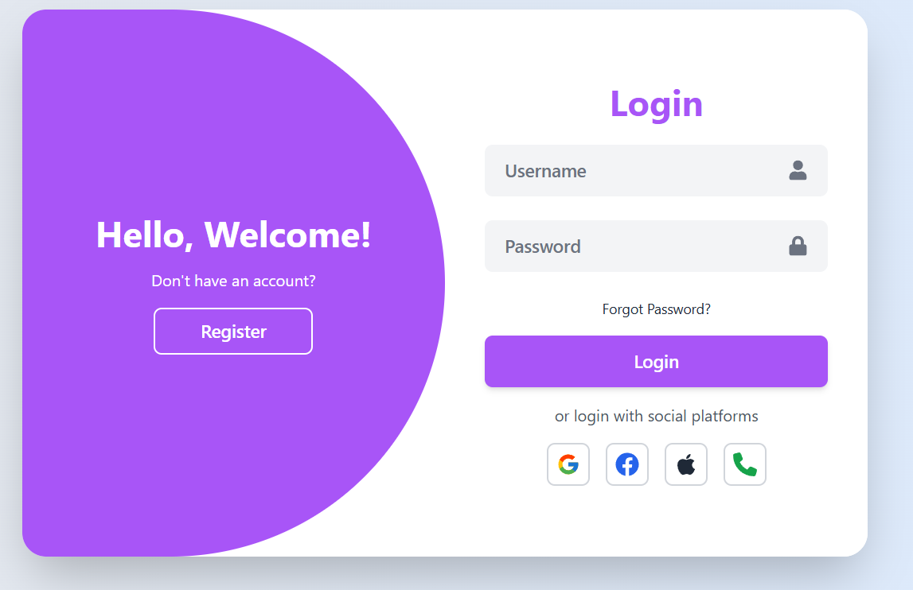

• In the registration function, users click the “Username” textbox input to enter their desired username, the “Email” textbox input to enter their email address, and the “Password” textbox input to enter their password.
• When they finish entering information, they must click the “Register” button to create a new account.
• Users can also register using social platforms like Google, Facebook, Apple, and Phone by clicking the respective icons.
• If users already have an account, they can click the “Login” button to access their account.
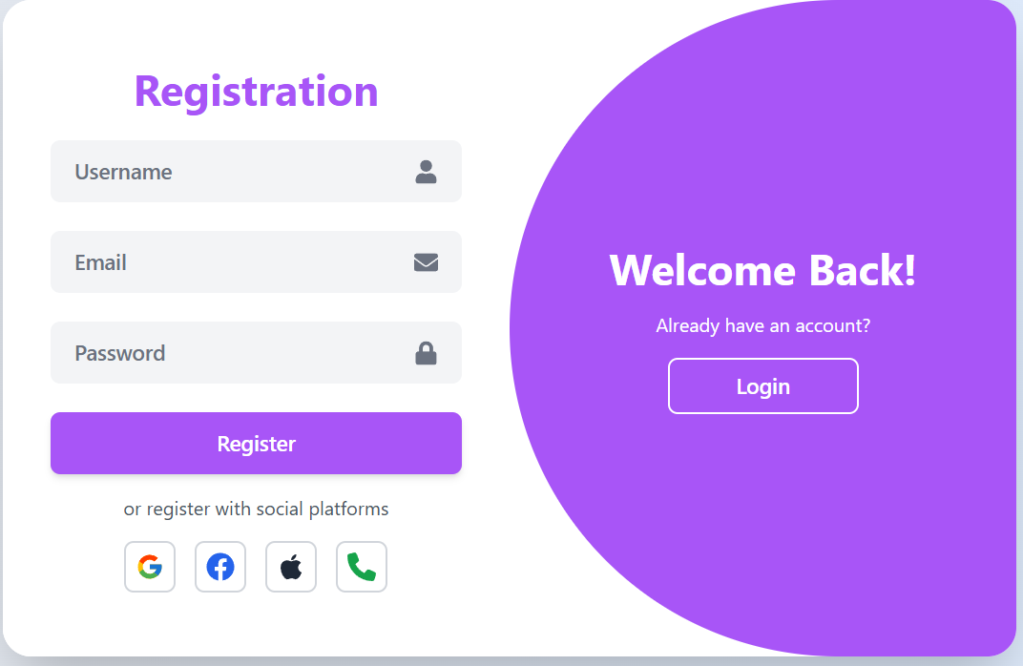
2. User Interface
In this user interface, we can see several key features, such as:
- Left navigation bar: Includes options like Home, Search, and Your Library, where users can create playlists or explore podcasts.
- Main content area: Displays featured music charts (Featured Charts) and the most popular songs at the moment (Today's biggest hits).
- Bottom music player: Shows the currently playing song, progress bar, playback controls (play/pause, skip, repeat, shuffle), and additional options like volume control and audio settings.
- Advanced options: In the top right corner, there are buttons for Explore Premium and Install App, allowing users to access extended features of the application.
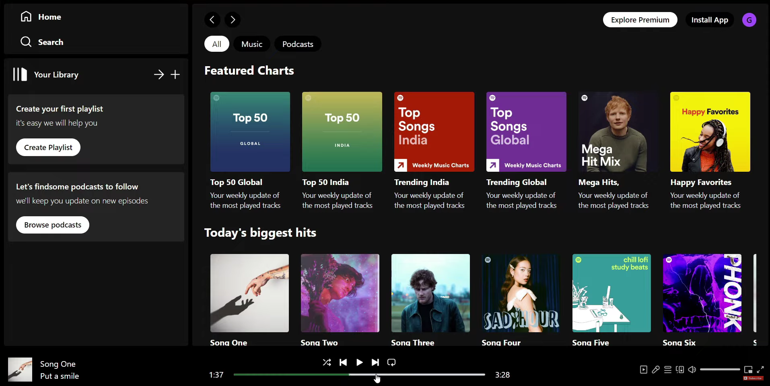
3. User Authentication
- The system shall allow users to register and log in using email or social media accounts.
- The system shall provide password recovery functionality.
4. Music Playback
- The system shall allow users to play, pause, skip, and adjust volume for music tracks.
- The system shall display track information (title, artist, album) during playback.
5. Chatbox AI
- The system shall analyze user listening history and preferences to generate personalized music recommendations.
- The system shall allow users to provide feedback on recommendations (like/dislike).

6. Playlist Management
- The system shall allow users to create, edit, and delete playlists.
- The system shall allow users to add or remove tracks from playlists

7. Search and Filter
- The system shall allow users to search for music by title, artist, or album.
- The system shall allow users to filter music by genre, mood, or activity.

3.2. Non-Functional Requirements
Performance
- The system shall load music recommendations within 2 seconds of user interaction to ensure a seamless browsing experience.
- The system shall support up to 10,000 concurrent users while maintaining optimal response times and minimizing server overload.
- The system shall utilize caching mechanisms and content delivery networks (CDNs) to enhance loading speeds and reduce latency.
- The system shall optimize database queries to retrieve and display music playlists efficiently without significant delays.
- The system shall maintain an average uptime of 99.9%, ensuring high availability and reliability for users.
Usability
- The system shall feature an intuitive UI/UX design, including clear navigation, visually appealing layouts, and minimal user friction.
- The system shall provide tooltips and step-by-step guidance for new users to help them understand key features.
- The system shall allow customizable user preferences, such as theme selection (light/dark mode) and personalized playlists, to improve user engagement.
- The system shall implement keyboard shortcuts and accessibility features to accommodate users with disabilities.
- The system shall undergo regular usability testing and collect user feedback for continuous improvement.

Security
- The system shall encrypt user data using industry-standard protocols (e.g., TLS 1.3 for transmission and AES-256 for storage) to protect sensitive information.
- The system shall implement role-based access control (RBAC) to restrict administrative privileges and prevent unauthorized access.
- The system shall enforce multi-factor authentication (MFA) for high-privilege accounts to enhance security.
- The system shall perform regular security audits and vulnerability assessments to identify and mitigate potential risks.
- The system shall log all user activities for security monitoring and compliance with data protection regulations.
Compatibility
- The system shall be compatible with major web browsers, including Google Chrome, Mozilla Firefox, Microsoft Edge, and Safari, ensuring a consistent experience across platforms.
- The system shall support multiple devices, including desktop, tablet, and mobile, with a responsive design that adjusts based on screen size.
- The system shall provide cross-platform synchronization, allowing users to access their accounts and playlists seamlessly across different devices.
- The system shall support native mobile applications for both Android and iOS, providing optimized experiences for mobile users.
- The system shall undergo compatibility testing to ensure smooth operation across various operating systems and device configurations.

3.3 System Attributes
Reliability
- The system shall maintain an uptime of 99.9%, ensuring minimal service interruptions and high availability for users.
- The system shall implement automated failover mechanisms to handle server failures and prevent downtime.
- The system shall have redundant data storage and backup systems to recover from unexpected failures.
- The system shall be capable of real-time monitoring to detect and resolve potential performance issues proactively.

Scalability
- The system shall support horizontal scaling, allowing additional servers to be added as user demand increases.
- The system shall utilize load balancing techniques to distribute traffic efficiently across multiple servers.
- The system shall support cloud-based deployment to ensure dynamic resource allocation and cost-effective scaling.
- The system shall be designed with microservices architecture, enabling independent scaling of individual services.
- The system shall accommodate growth from 10,000 to 100,000+ concurrent users without significant performance degradation.
Maintainability
- The system shall follow a modular architecture, making it easier to update, modify, and maintain individual components.
- The system shall have comprehensive documentation for developers and administrators to streamline maintenance and troubleshooting.
- The system shall be built with version control and automated deployment pipelines to facilitate seamless updates.
- The system shall allow for hotfixes and patches to be applied without significant downtime.
- The system shall include logging and monitoring tools to track errors, diagnose issues, and improve system performance over time.

4. Specific Requirements
This section outlines additional requirements related to the operating and development environments necessary for the successful implementation and deployment of the system, based on the current tech stack.

4.1 Operating Environment
- The system shall be deployed on a cloud-based infrastructure (e.g., AWS, Azure, or Google Cloud) to ensure scalability and high availability.
- The system shall support containerization using Docker and Kubernetes for efficient deployment and orchestration.
- The system shall be optimized for high-performance Node.js and Spring Boot backend services to handle real-time data processing and API requests.
- The system shall be accessible via modern web browsers (Chrome, Firefox, Edge, Safari) and responsive on mobile devices.

4.2 Development Environment
- The development team shall use Node.js, React.js, and Spring Boot as the core technology stack for backend and frontend development.
- The database shall be managed using MongoDB, ensuring flexible and scalable data storage.
- The UI shall be built using Tailwind CSS for a modern and responsive design.
- The project shall be managed using JIRA, with Agile methodologies (Scrum/Kanban) to track progress and issue resolution.
- The codebase shall be maintained with GitHub Desktop, following best practices in branching (e.g., feature branches, pull requests, and code reviews).
- The system shall support CI/CD pipelines to automate testing, integration, and deployment processes.

5. Analysis Models

5.1. Data Flow Diagram
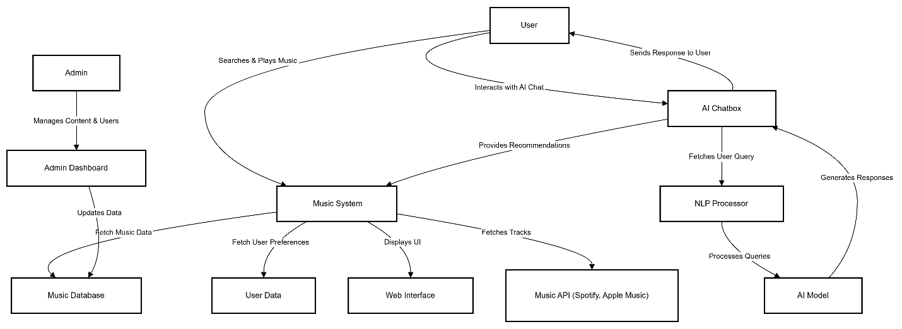
Explanation of the Data Flow Diagram (DFD) for Your Music Website with AI Chatbox
This Level 1 DFD provides a high-level overview of how data flows through your music streaming website with an AI-powered chatbox. The system consists of multiple components, each handling specific tasks.
Key Components & Their Roles
1. Users
- The user is the main actor who interacts with the system.
- They search for music, play songs, and chat with the AI chatbox.
- The data flows from the user to the system based on their actions.
2. Music System
The core of your platform, responsible for handling:
- Music Search & Playback: Retrieves songs from the Music Database.
- User Preferences: Fetches user data (like playlists, favorites) from the User Database.
- Displaying Content: Sends the processed information to the UI/Web Interface.
3. Databases
- Music Database: Stores song metadata (title, artist, album, genre, etc.).
- User Data: Stores user-related data (preferences, history, playlists).
4. AI Chatbox
This is the smart assistant that interacts with users.
- Processes user messages and understands intent.
- Retrieves relevant recommendations from the Music System.
- Sends responses back to the user.
Inside the AI chatbox:
- NLP Processor: Understands user queries using Natural Language Processing (NLP).
- AI Model: Uses machine learning to generate responses and recommendations.
5. External Integrations
- Music API (Spotify, Apple Music, etc.): Fetches additional music data (like trending songs, real-time lyrics).
- Admin Dashboard: Allows admin users to manage songs, users, and content.

5.2. Usecase Diagram
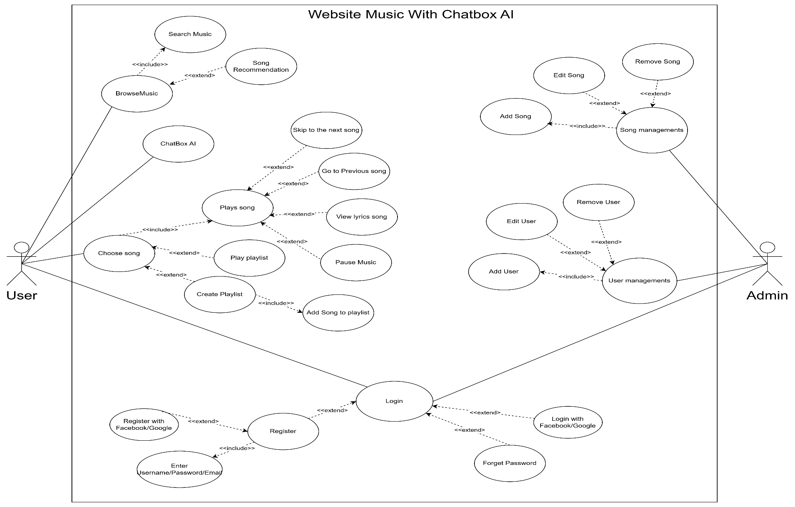
This Use Case Diagram represents a Website Music System with Chatbox AI. It includes various functionalities related to music browsing, playlist management, AI-based recommendations, user management, and authentication. Below is a breakdown of the key elements:
Actors:
- User – The primary actor who interacts with the system.
- Admin – Responsible for managing users and songs.
Use Cases and Relationships:
1. Music Browsing and Playback
- Browse Music (includes):
  - Search Music
  - Song Recommendation
- Chatbox AI interacts with music browsing.
- Choose Song (includes):
  - Play Song (extends):
    - Skip to the next song
    - Go to the previous song
    - Pause Music
    - View Lyrics Song
- Play Playlist (extends Play Song)
- Create Playlist
- Add Song to Playlist
2. Authentication
- Login (includes):
  - Login with Facebook/Google
  - Forget Password
- Register (includes):
  - Register with Facebook/Google
  - Enter Username, Password, Email
3. Song Management (Admin)
- Song Management (includes):
  - Add Song
  - Edit Song
  - Remove Song
4. User Management (Admin)
- User Management (includes):
  - Add User
  - Edit User
  - Remove User
Relationships:
- Includes ("<<include>>"): A mandatory dependency where one use case is required for another.
- Extends ("<<extend>>"): An optional dependency where one use case adds additional behavior to another.
This diagram illustrates how users interact with the music system to browse, play, and manage playlists, while admins handle user and song management. The Chatbox AI is integrated for music recommendations and interactions, and authentication allows users to log in via various methods.

5.3. Activity Diagram

5.3.1. Activity diagram of login function
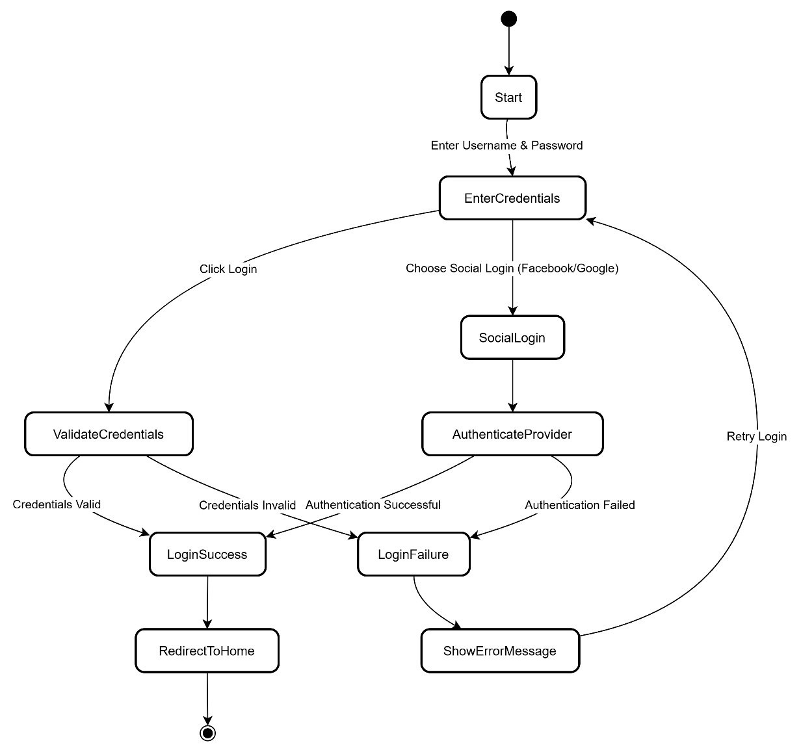
This activity diagram represents the login process of a system, including standard login and social login (Facebook/Google).
Steps in the Login Process:
- Start: The process begins when a user wants to log in.
- Enter Username & Password: The user provides their credentials (username and password).
- The system provides two login options:
  - Click Login: Standard login using username & password.
  - Choose Social Login (Facebook/Google): Uses external authentication.
Standard Login Flow
- Validate Credentials: The system checks the username and password.
- The system determines the result:
  - If credentials are valid → LoginSuccess: The user is logged in.
  - If credentials are invalid → LoginFailure: The system displays an error message and allows a retry.
Social Login Flow
- Authenticate Provider: The system redirects the user to Facebook/Google for authentication.
- The system checks the result:
  - If authentication is successful → LoginSuccess: The user is logged in.
  - If authentication fails → LoginFailure: The system displays an error message and allows a retry.
Final Step
- Redirect to Home: If login is successful, the user is directed to the home screen.
- Retry Login: If login fails, the user can retry the process.

5.3.2 Activity Diagram of AI Music Recommendation
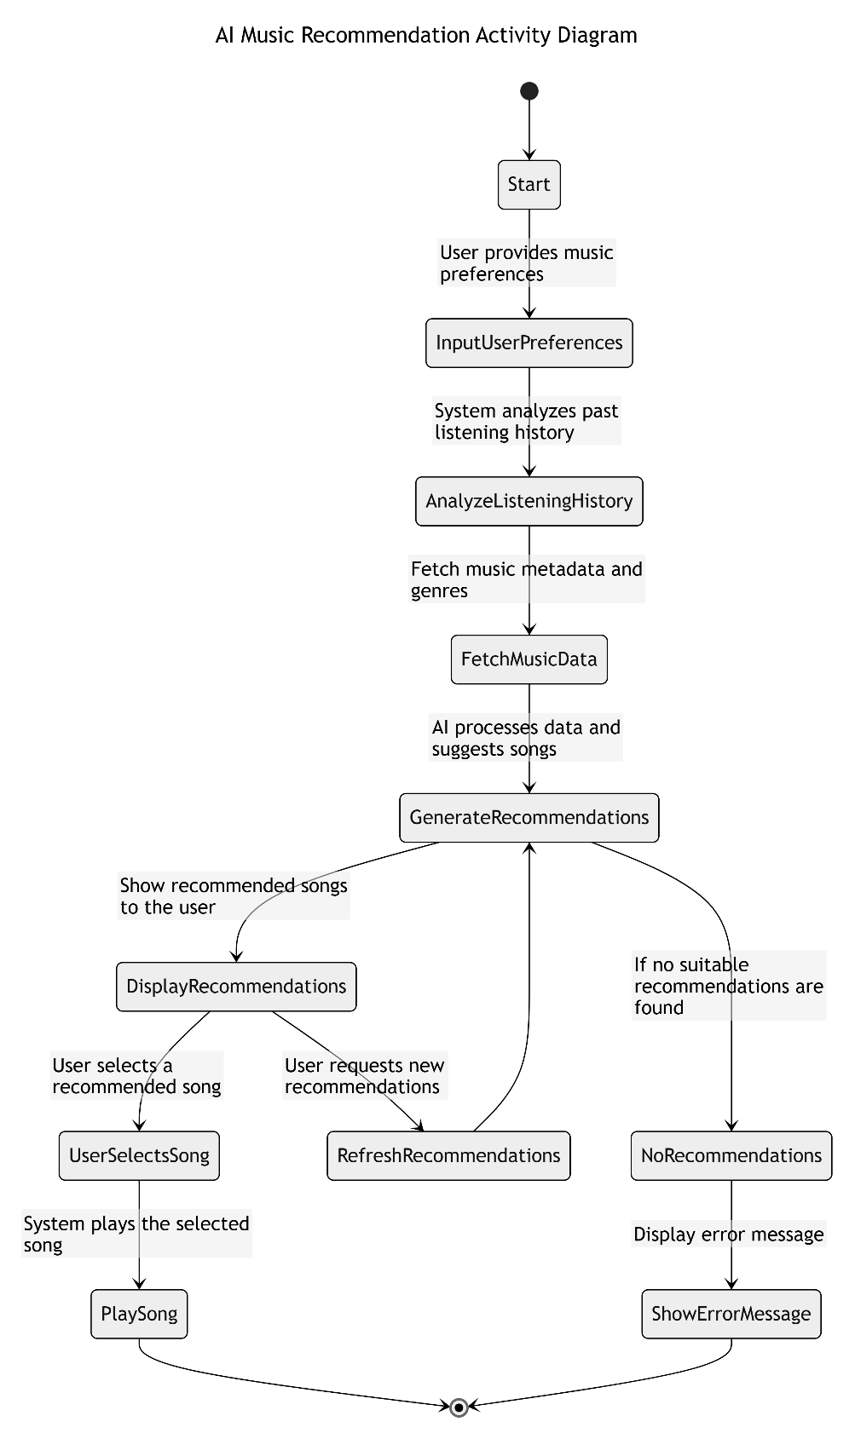
This activity diagram represents the AI Music Recommendation process, outlining how an AI system suggests songs to a user based on preferences and listening history.
Step-by-step Breakdown:
- Start:
  - The process begins when the user interacts with the music recommendation system.
- User Provides Music Preferences:
  - The user inputs their preferences, such as favorite genres, moods, or artists.
- Analyze Listening History:
  - The system reviews past listening behavior to better understand the user’s taste.
- Fetch Music Metadata and Genres:
  - The system retrieves information about available songs, including metadata such as genre, artist, and popularity.
- AI Processes Data and Suggests Songs:
  - The AI algorithm analyzes the gathered data and generates personalized song recommendations.
- Display Recommended Songs to the User:
  - The system presents the recommended list of songs to the user.
- User Selects a Recommended Song:
  - If the user picks a song, the system proceeds to play it.
- System Plays the Selected Song:
  - The chosen song starts playing.
- User Requests New Recommendations (Optional):
  - The user can ask for a refreshed set of recommendations, prompting the AI to generate a new list.
- No Suitable Recommendations Found (Error Handling):
  - If the AI cannot generate valid recommendations, the system triggers an error.
- Display Error Message:
  - An error message is shown to the user if no recommendations are available.
- End:
  - The process completes once the song is played or an error is displayed.
This diagram provides a clear visual workflow of how AI-powered music recommendations function in a music streaming application.
5.3.3. Activity Diagram for Playlist Management 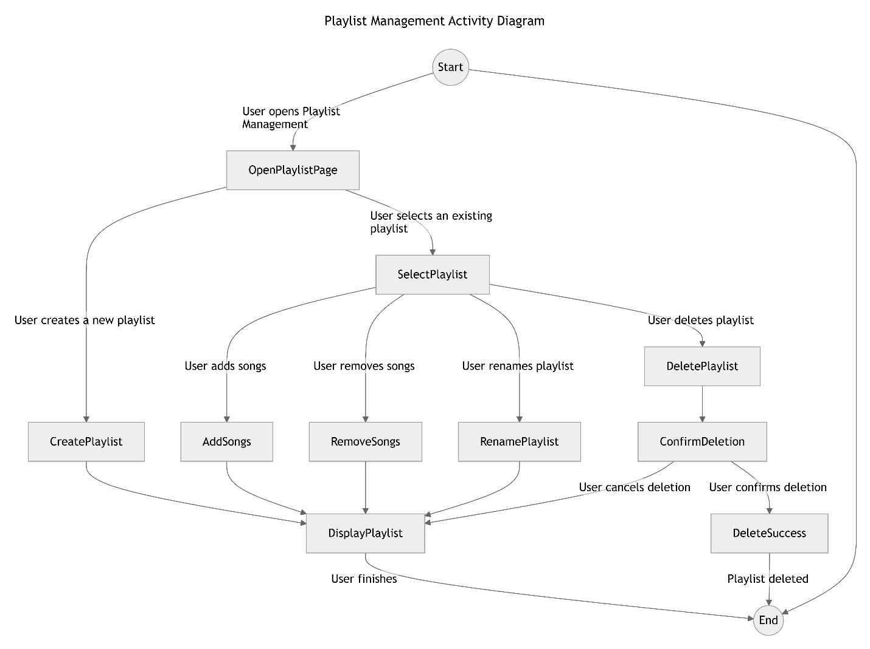
This Activity Diagram for Playlist Management visually represents the user’s actions when managing a playlist in a music application. Below is a detailed breakdown of its flow:
Diagram Breakdown
- Start Node: The process begins.
- User Opens Playlist Management: The user accesses the playlist management interface (OpenPlaylistPage).
- User Actions: The user has multiple options:
  - Create a new playlist (CreatePlaylist) → The playlist is displayed (DisplayPlaylist).
  - Select an existing playlist (SelectPlaylist), then:
    - Add songs (AddSongs) → Updates and displays the playlist.
    - Remove songs (RemoveSongs) → Updates and displays the playlist.
    - Rename the playlist (RenamePlaylist) → Updates and displays the playlist.
    - Delete the playlist (DeletePlaylist), leading to:
      - Confirmation step (ConfirmDeletion):
        - If the user cancels → Returns to displaying the playlist.
        - If the user confirms (DeleteSuccess) → The playlist is deleted.
- User Finishes: Once the user is done managing the playlist, the process ends.
This SRS document provides a comprehensive overview of the requirements for the "Web Application for Listening to Smart Music Suggestions with AI." It serves as a guide for developers, stakeholders, and testers to ensure the system meets user needs and expectations.

